Blank COSHH Assessment Form

COSHH Risk Assessment Record |  | Ref:
Project/Premises: |  | Company:
Substance/Material: |  | Hazardous Contents:
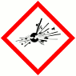 |  | 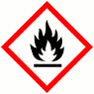 |  | 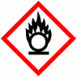 |  | 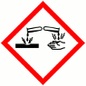 |  | 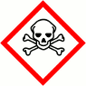 |  | 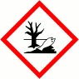 |  |  |  | 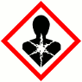 |  | 
Explosive |  | Flammable |  | Oxidising |  | Corrosive |  | Acute Toxicity |  | Hazardous to the Environment |  | Health Hazard |  | Serious Health Hazard |  | Gas Under Pressure
Yes | No | Yes | No | Yes | No | Yes | No | Yes | No | Yes | No | Yes | No | Yes | No | Yes | No

Location:
Process: |  |  |  |  |  |  | Activity:
Frequency of Exposure: |  |  |  |  |  |  | Duration of Exposure:
Risk to Health:
Control Measures:
Storage: |  |  |  |  |  |  | Disposal:
Spillage: |  |  |  |  |  |  | Fire Information:
First Aid:
Eye Contact: |  |  |  |  |  |  |  | Inhalation:
Skin Contact: |  |  |  |  |  |  |  | Ingestion:
Other Controls: |  |  |  | Monitoring: |  |  |  |  |  | Health Surveillance:
Tick applicable |  |  |  | Record  Attached |  | ☐ |  | Not  Applicable | ☐ | Record  Attached |  |  | ☐ | Not  Applicable |  | ☐
Training/Instruction Required
Verbal Instruction: (please delete one) |  | Yes |  |  | No |  |  | Written Instruction: (please delete one) |  |  | Yes |  |  |  | No
Toolbox Talk: (please delete one) |  | Yes |  |  | No |  |  | Specialist Training: (please delete one) |  |  | Yes |  |  |  | No
Assessed by: |  |  |  |  |  |  |  | Position:
Date: |  |  |  |  |  |  |  | Review Date:

